**Visualization Wheel**

In this conceptualization there are two poles of a circle. The top one represents highly complex data which informs at a deep level. While the bottom provides easier access to data but only informs in a shallow manner. Inside the circle are dimensions which describe tradeoffs between two approaches.

1. **Common Trade-offs -**
2. *Abstraction - Figuration:*

A highly figurative visual describes the phenomenon using physical representations of the phenomena, such as photographs or drawings. As the representations become less real and more conceptual, the emphasis shifts from figuration to abstraction.

1. *Functionality - Decoration:*

A completely functional graphic has no embellishments and is closer to a direct representation of the data. While a heavily decorated graphic has more artistic embellishments.

1. *Density - Lightness:*

Relates to the amount of information being shown. For example, the figure below

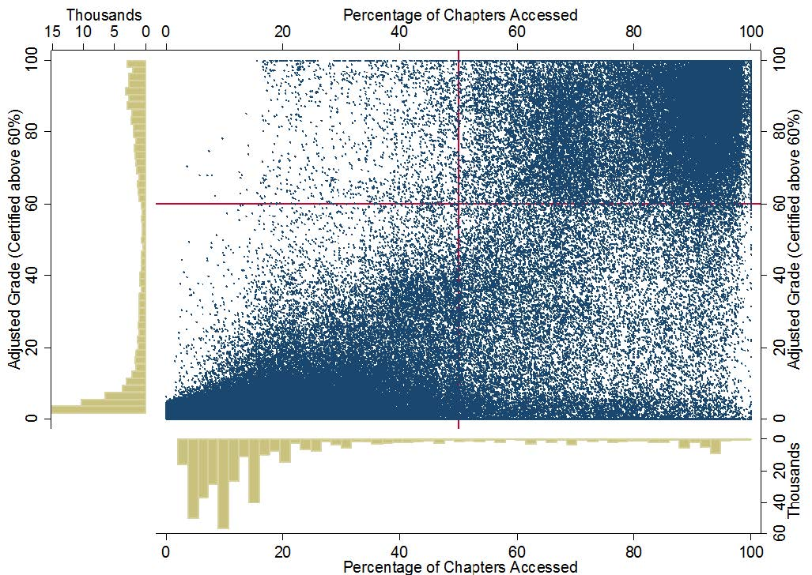

This figure above is considered above to be fairly densed.

1. *Multidimensional - Unidimensional:*

A multidimensional graphic describes a phenomena as a whole and invites the viewer to explore many different aspects of the phenomena. A unidimensional graphic instead focuses on a single or a few items and explores them in one or more ways.

1. *Originality - Familiarity:*

For example, the graph of Napoleon's march into Russia in 1812 describes that there are five different kinds of information being visualize in this graphic. Example: First there are elements of geography showing us the various rivers in towns along the way. The width of the tan upper bar represents the size of Napoleon's army, and you can see it shrinks from the beginning of the campaign from 422,000 to only 100,000 once the French reach Moscow. The lower black bar shows Napoleon's retreat from Russia, and there are various points along it which are mapped to dates and temperatures in Celsius. We see the bar thins dramatically as the army shrinks in size. So, the five variables are location, direction, temperature, army size and dates.

1. *Novelty - Redundancy:*

Redundancy is the tendency of a graphic to tell the same story in many different ways, while, novelty is the act of describing each phenomena in the graphic in only one way.

## **2. Radar Plot -**

## On the left hand side you see there is more emphasis towards complex visuals. Those which are dense, multidimensional and have high functionality. On the right, you see the visualization wheel. There are more elements of decoration, lightness, and figuration. Cairo suggests that the left wheel is more indicative of work being done by scientists and engineers, while the right wheel is more indicative of work being done by artists, graphic designers, and journalists.

